**Introduction to Artificail Intelligence(IAI)**

Table of Contents

Artificial Intelligence 1

Introduction | AI | Lec-01 2

Screenshot-1 2

Screenshot-2 2

Why & Goals | Lec-02 3

Screenshot-1 3

Screenshot-2 3

Screenshot-3 4

Screenshot-4 4

Screenshot-5 5

Intelligence composed of | Lec-03 5

Screenshot-1 5

Screenshot-2 6

Agents in AI | Part-1/2 | Lec - 04 6

Screenshot-1 6

Screenshot-2 7

Screenshot-3 7

Screenshot-4 8

Agents in AI | Part-2/2 | Lec - 04 8

Screenshot-1 8

# Artificial Intelligence

YouTube [link](https://www.youtube.com/playlist?list=PLrjkTql3jnm_yol-ZK1QqPSn5YSg0NF9r)

## Introduction | AI | Lec-01

### Screenshot-1

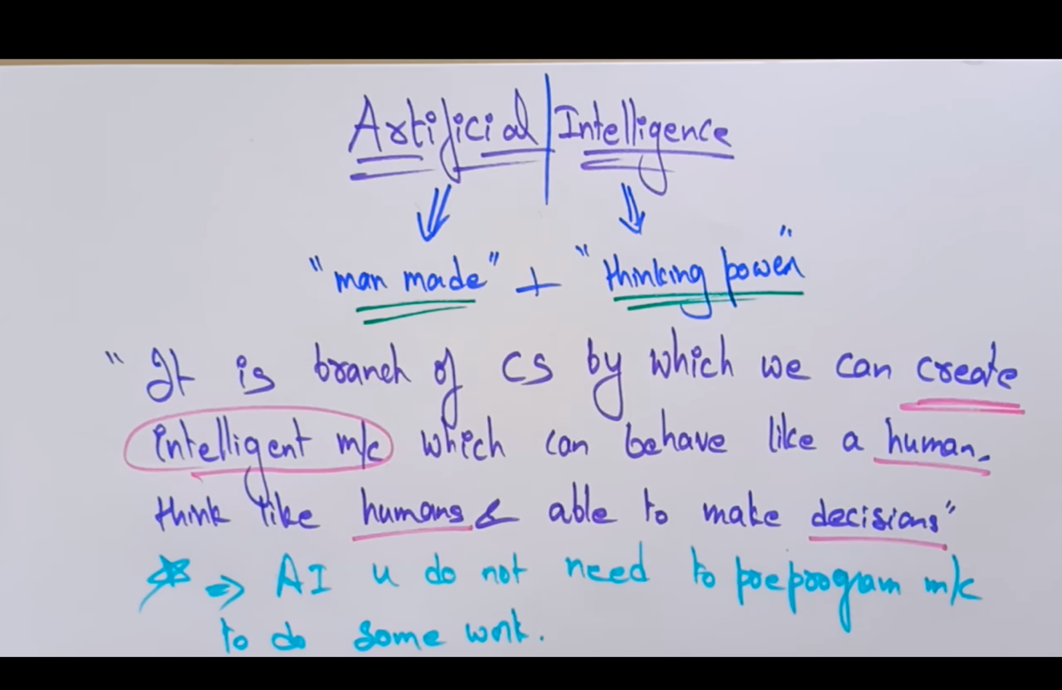

### Screenshot-2

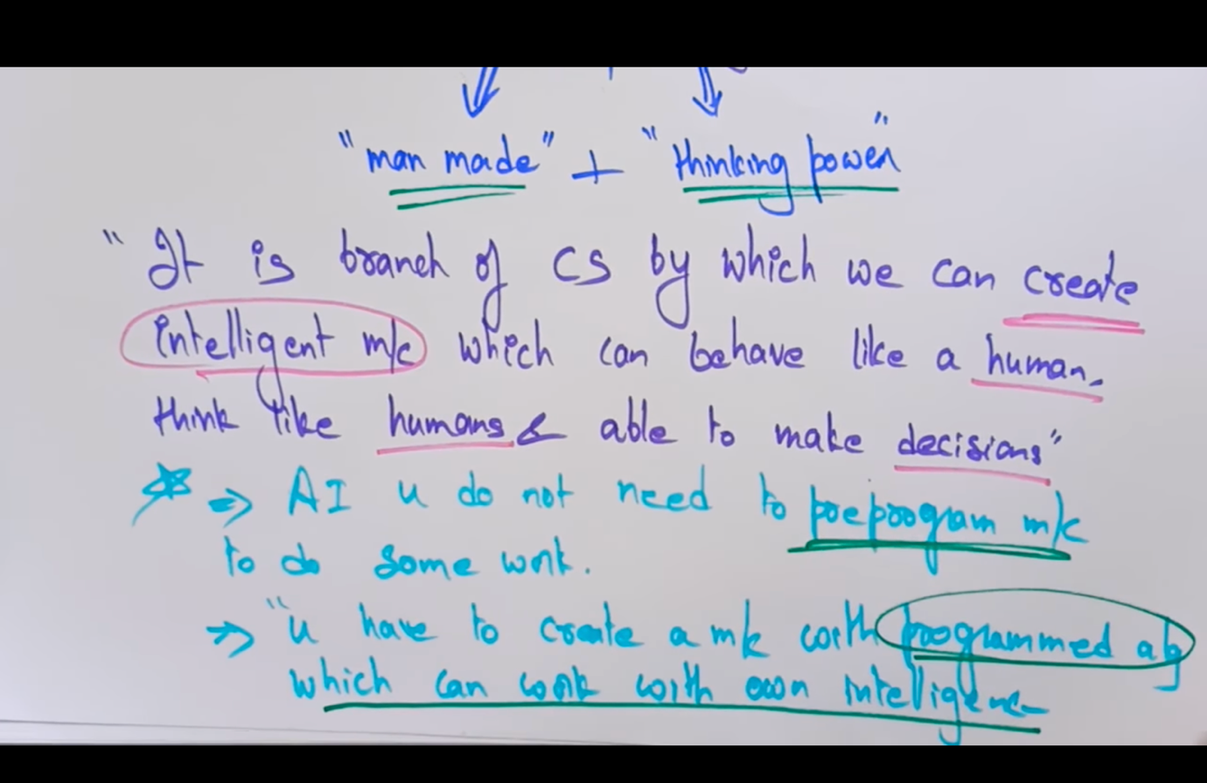

## Why & Goals | Lec-02

### Screenshot-1

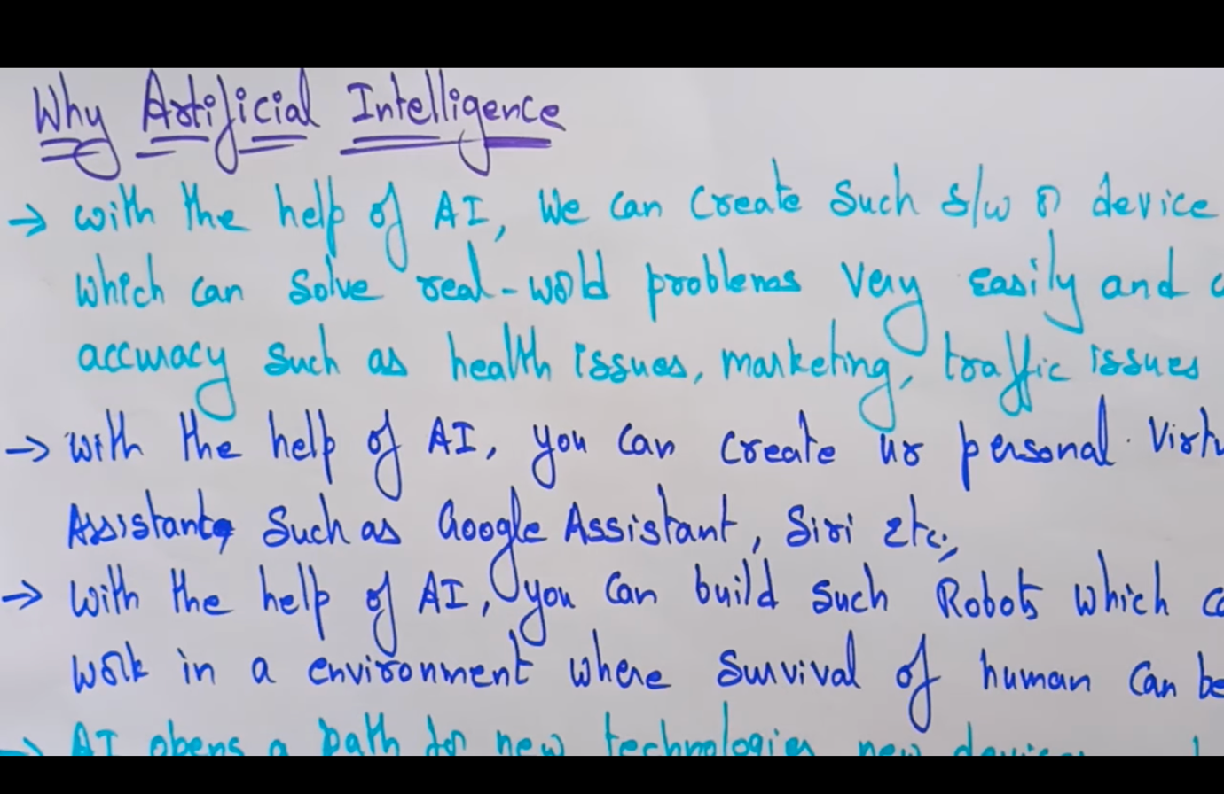

### Screenshot-2

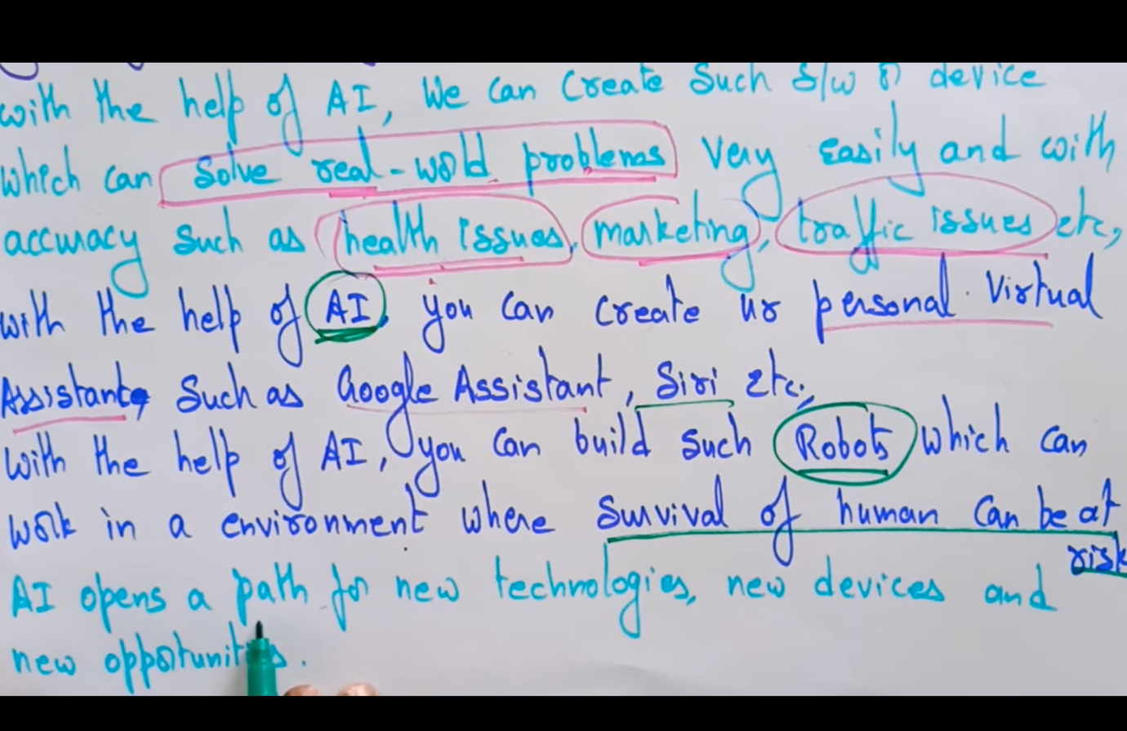

### Screenshot-3

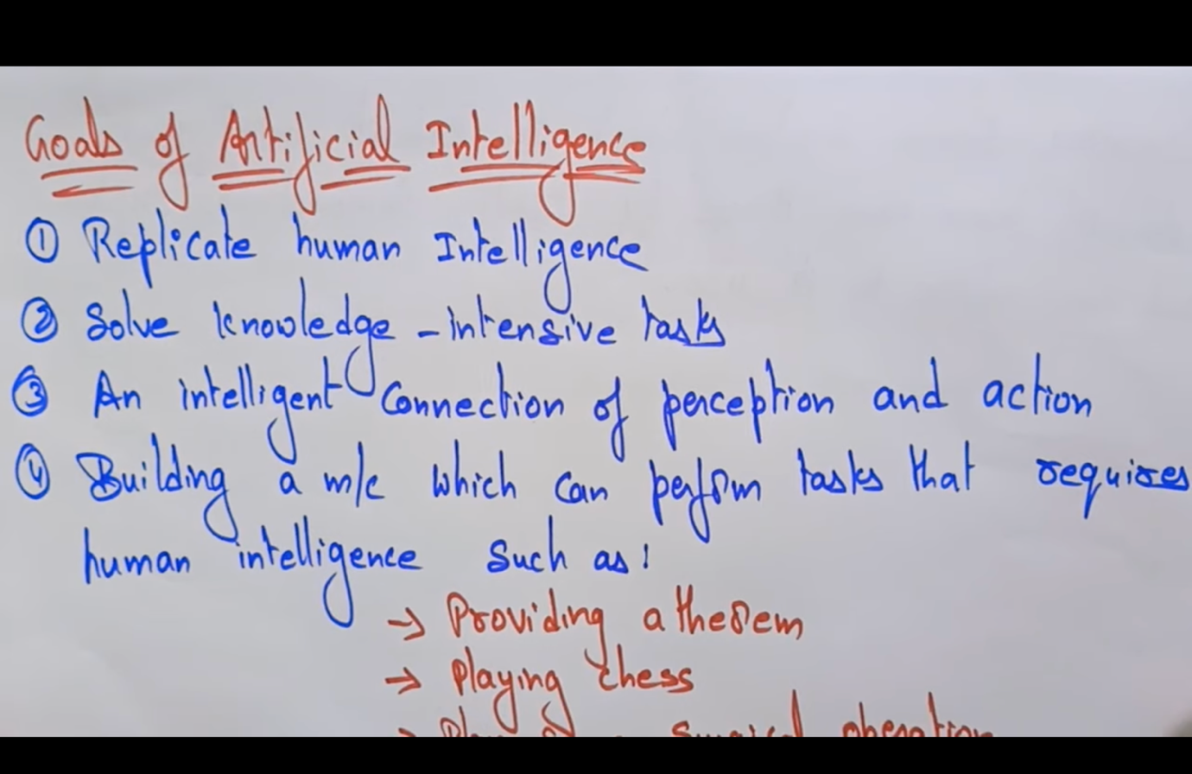

### Screenshot-4

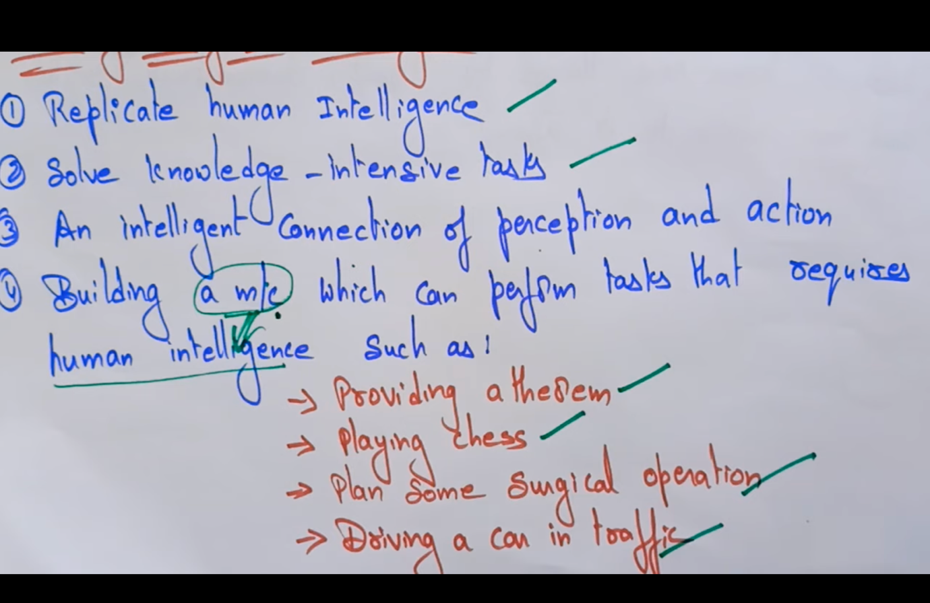

### Screenshot-5

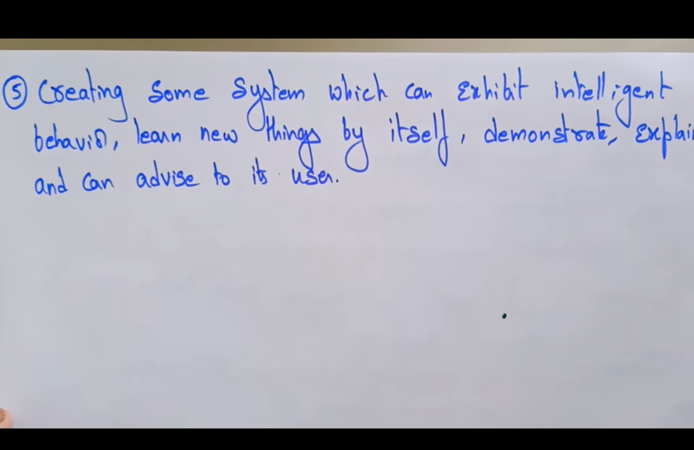

## Intelligence composed of | Lec-03

### Screenshot-1

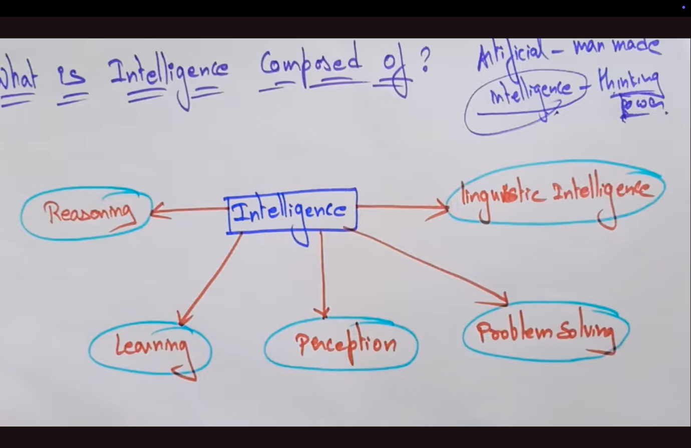

### Screenshot-2

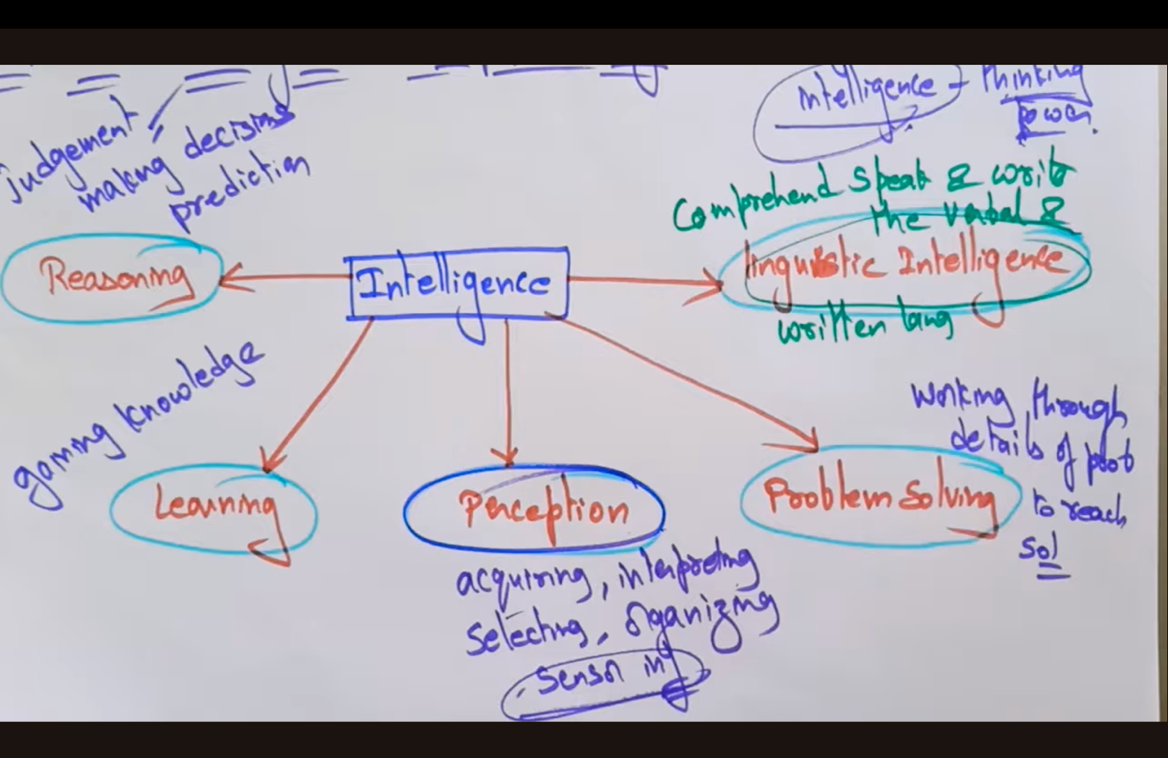

## Agents in AI | Part-1/2 | Lec - 04

### Screenshot-1

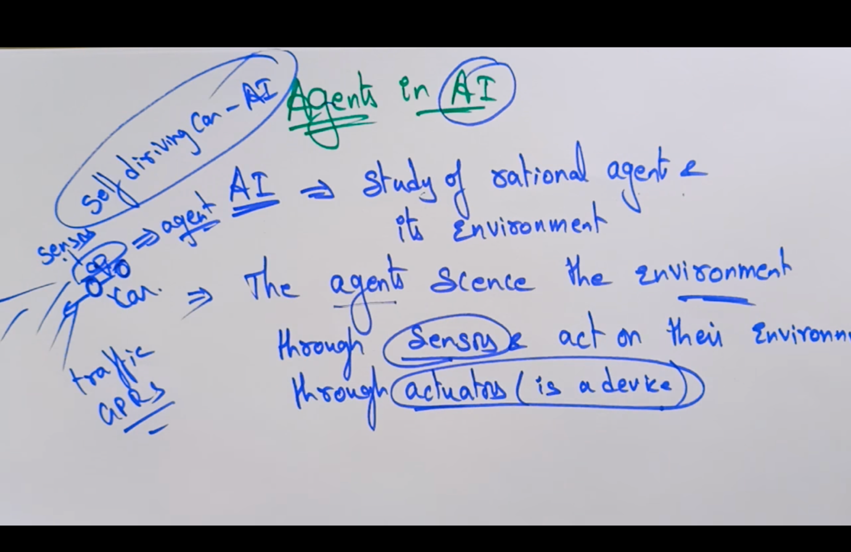

### Screenshot-2

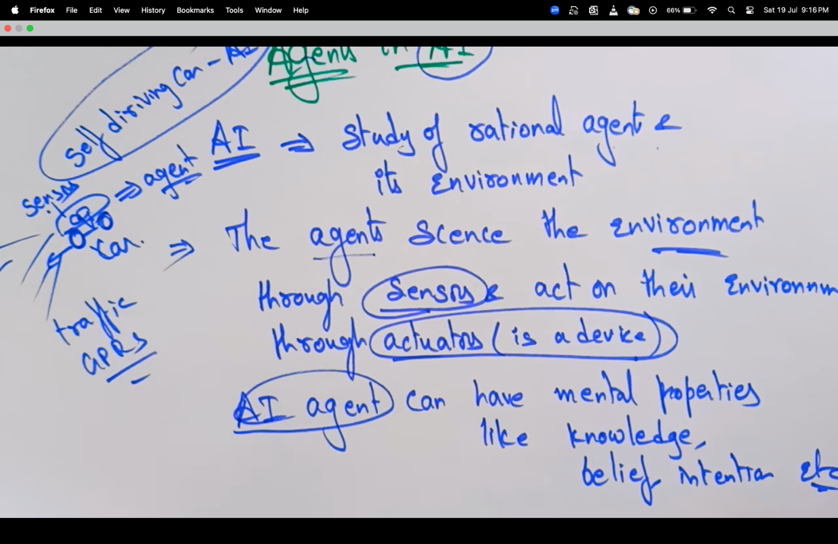

### Screenshot-3

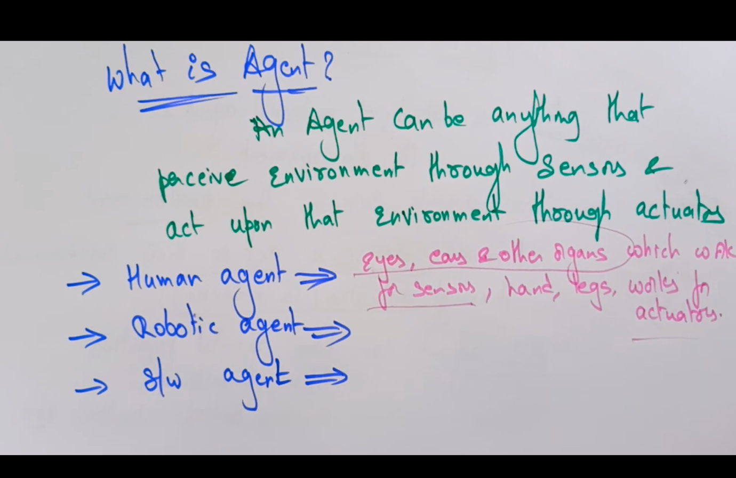

### Screenshot-4

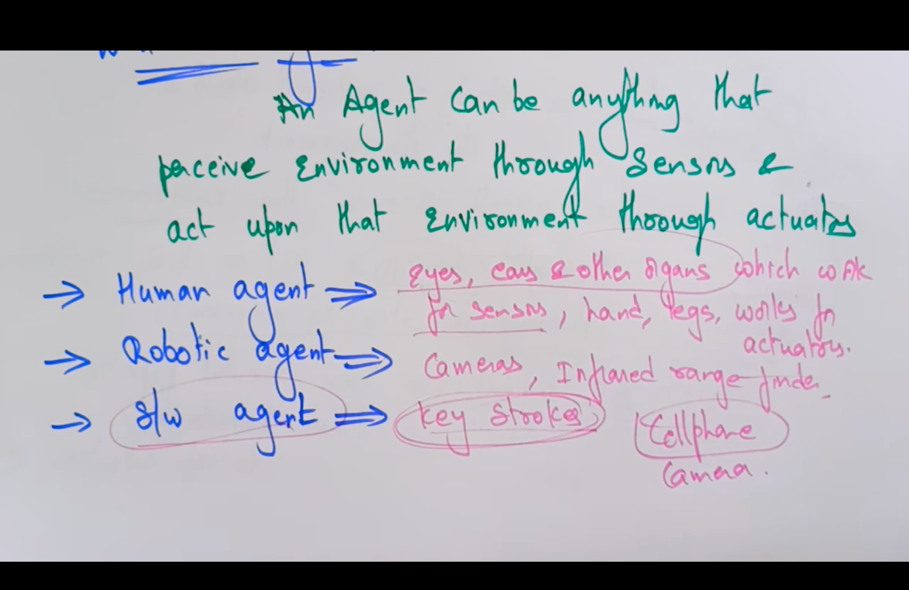

## Agents in AI | Part-2/2 | Lec - 04

### Screenshot-1